SPIDER CYBERSECURITY TASK

FOUND LOGS AT TASKMANAGER.CZ OF LOGIN

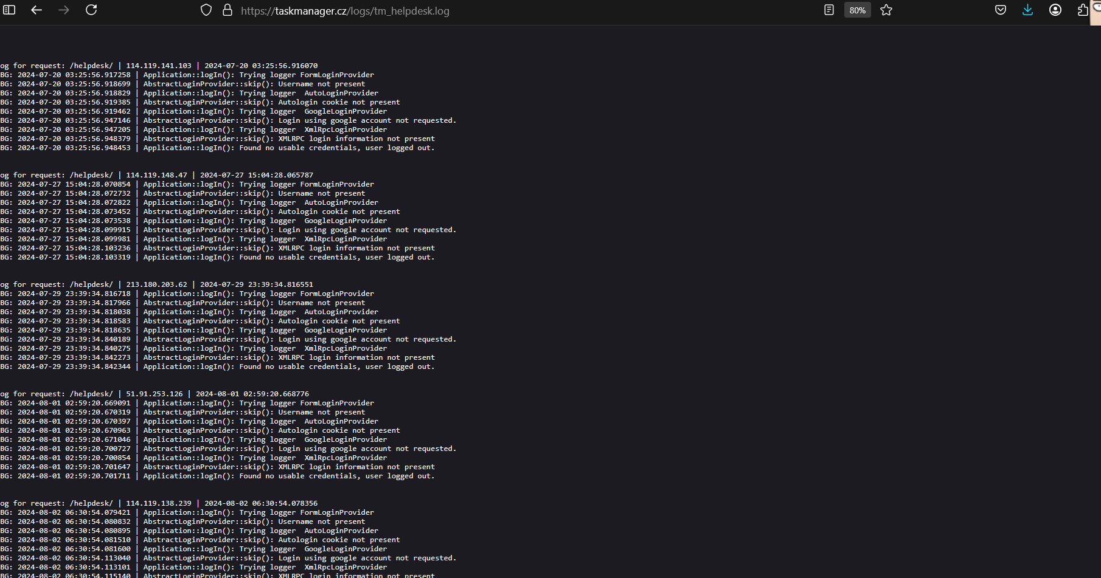

Found log file of oracle

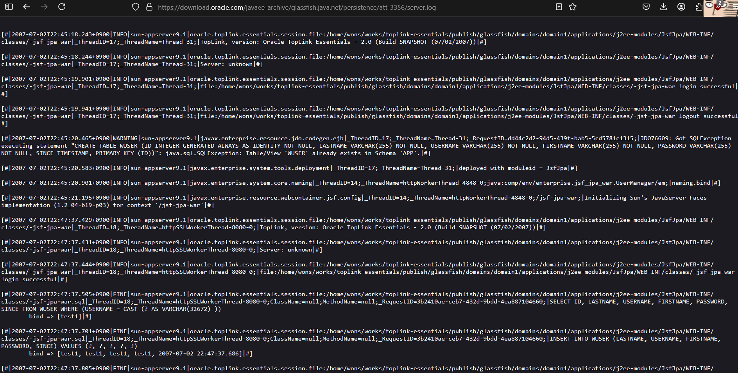

Password info of ANS Group

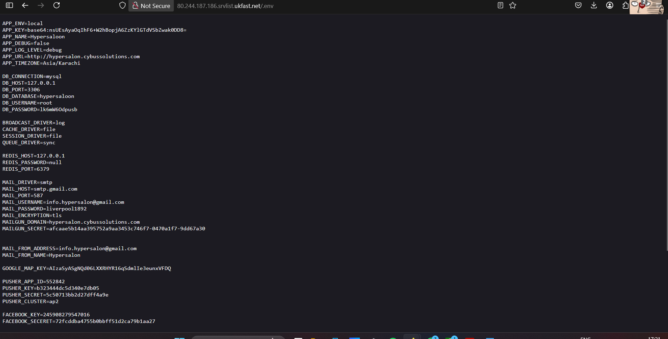

B.lal pharmacy password env file

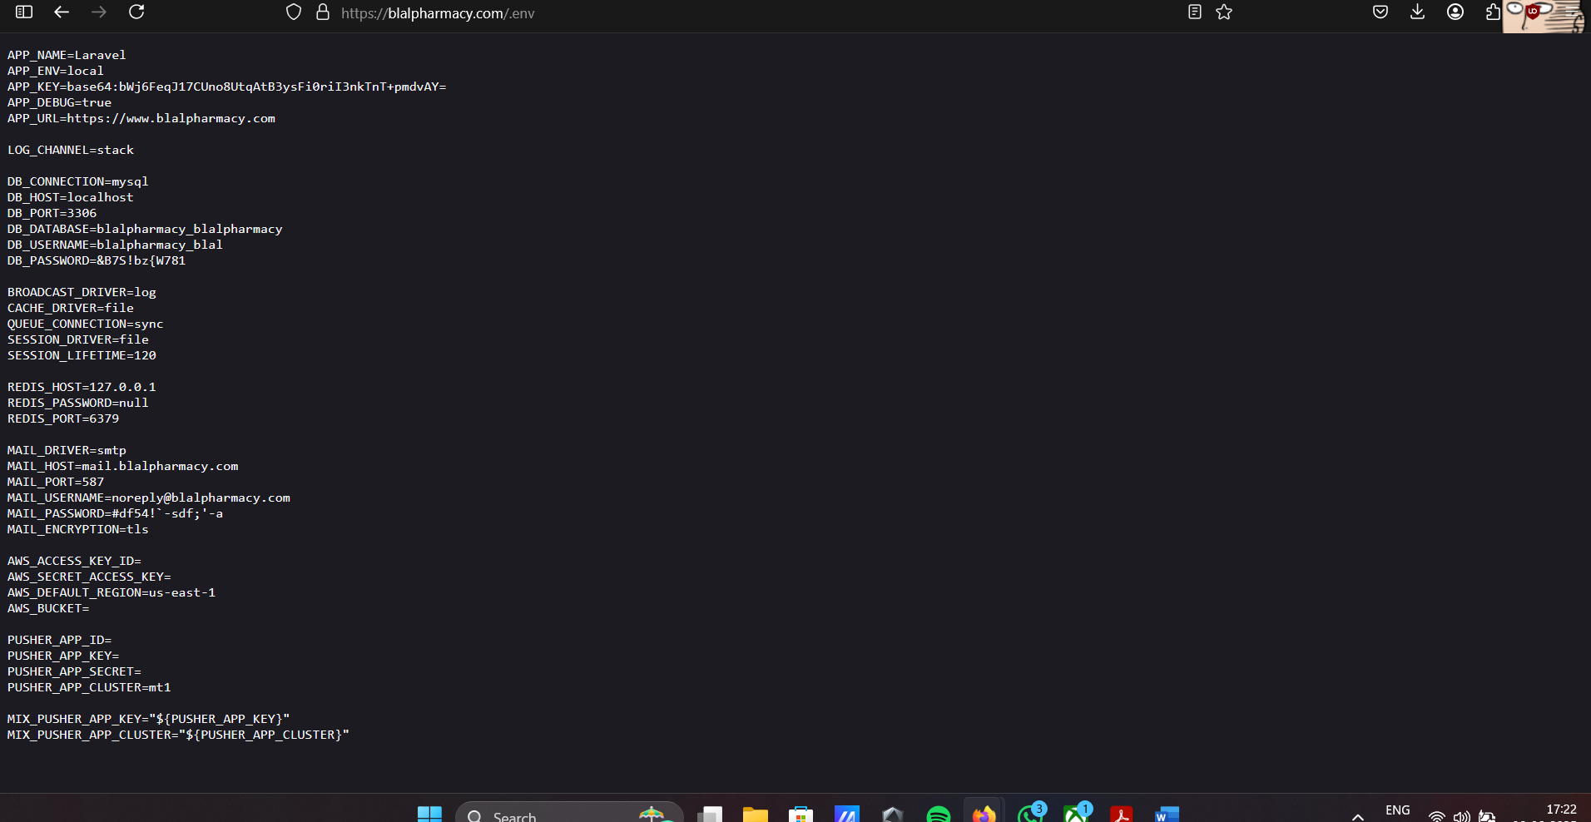

Employee salary data available at isro propulsion

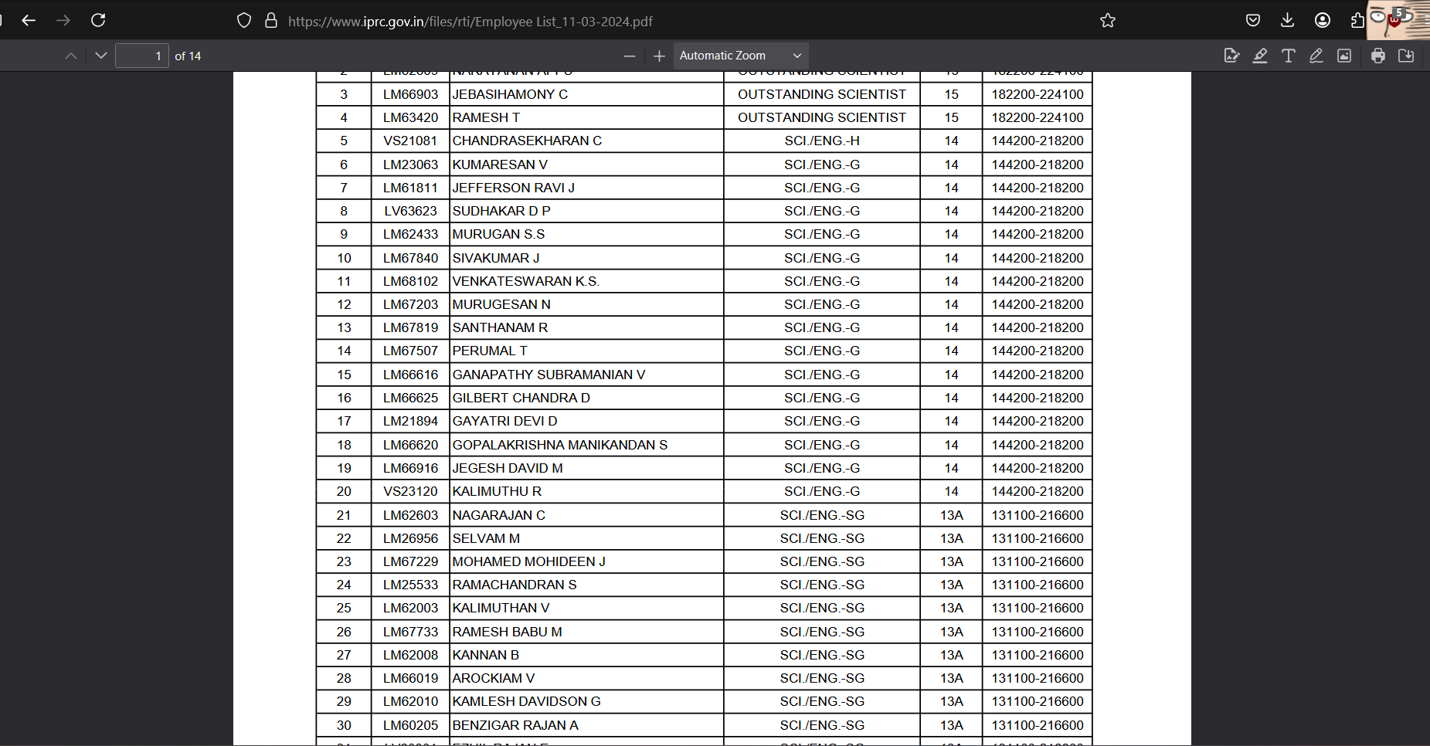

Another employee data with phone numbers

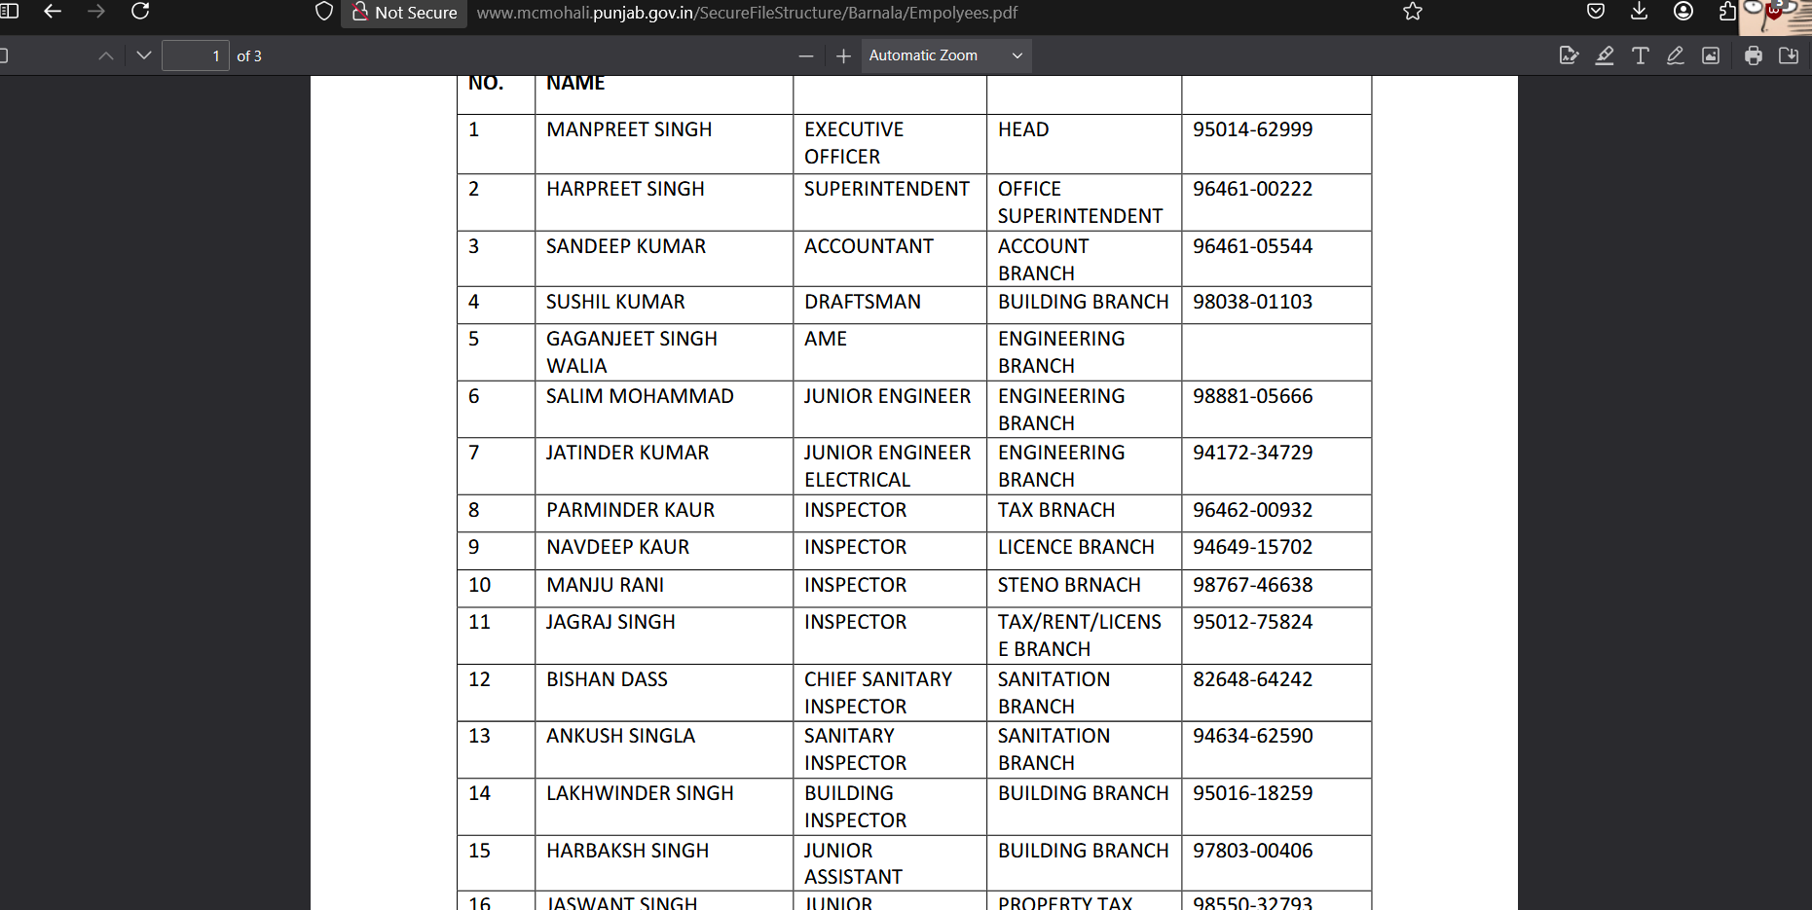

Config Files of terracotta.org , site – https://www.terracotta.org/tc-config.xmlhttps://www.terracotta.org/tc-config.xml

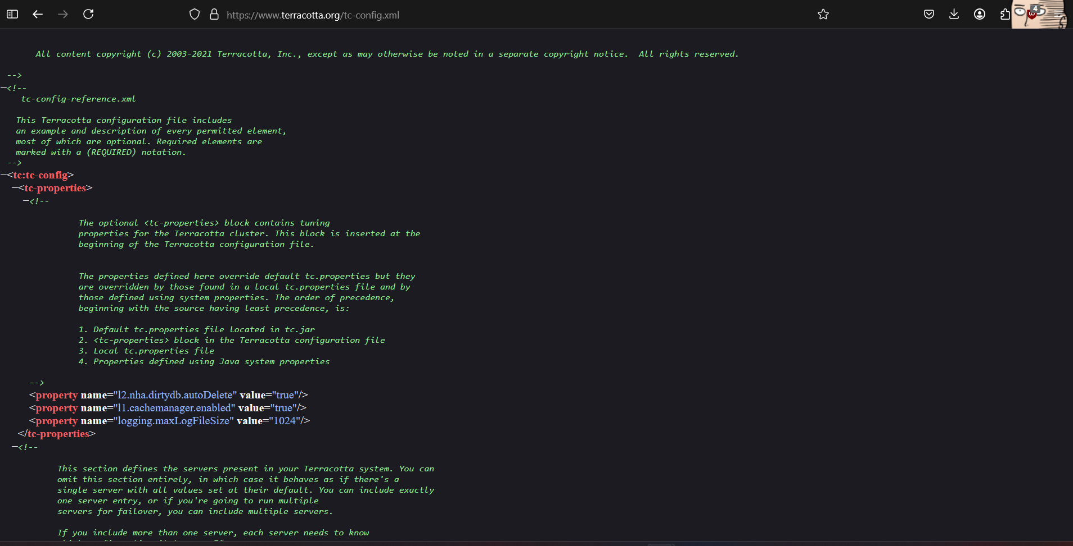

City od Houston(.gov) config file , site - https://www.houstontx.gov/planning/_cmp/CTP/apps/zh_CN/config.xml

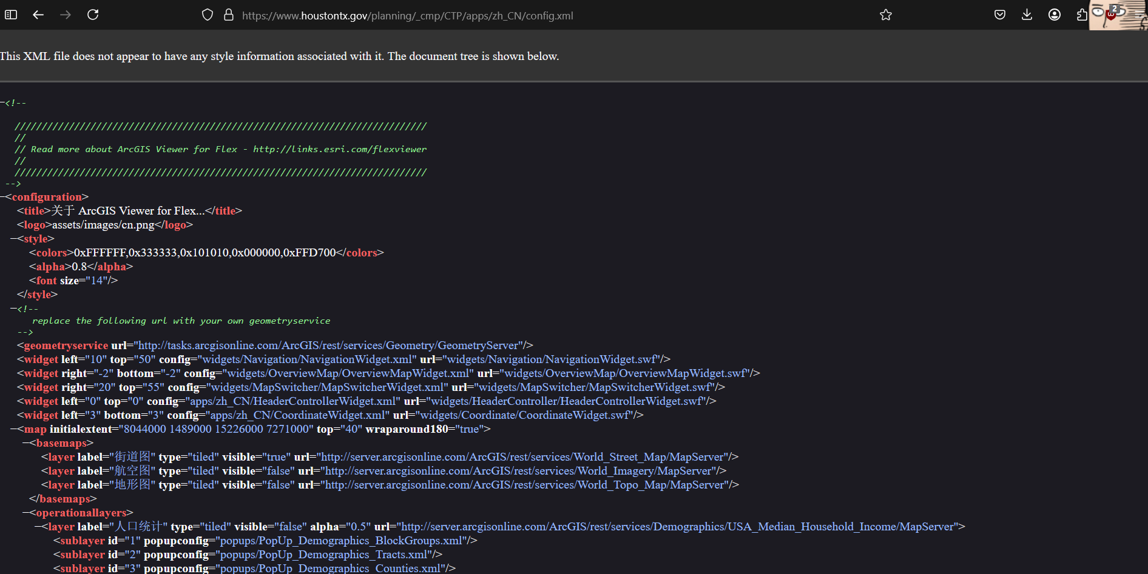

Pizza Hut employee login page

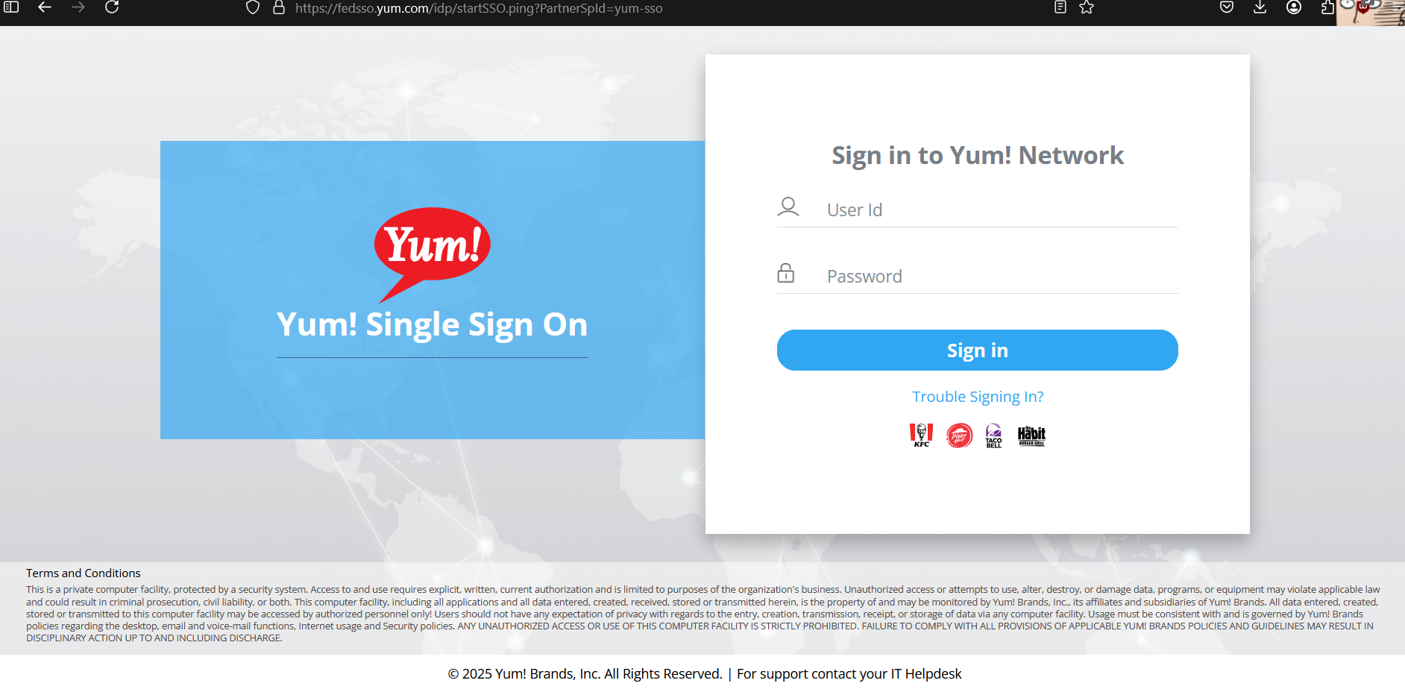

Nashik Municipal Coorporation admin login page https://civicservices.nmc.gov.in/admin/login

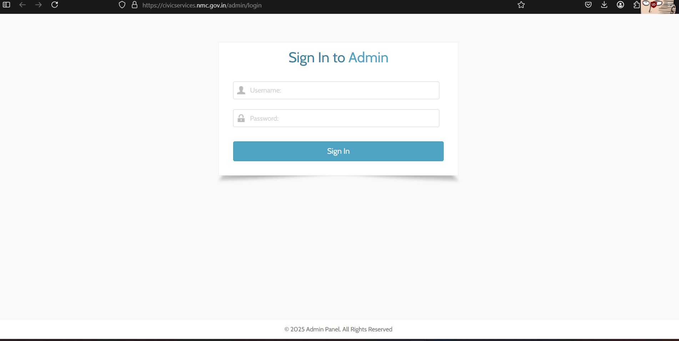

Public Document –

Snapdeal <https://sellers.snapdeal.com/servlet/servlet.FileDownload?file=0156F00000C2SstQAF>

Swiggy earning conference call transcript

<https://www.swiggy.com/corporate/wp-content/uploads/2024/12/Swiggy_Confcalltranscript_Q2FY25.pdf>